# Coil Driver Manual (Preliminary)

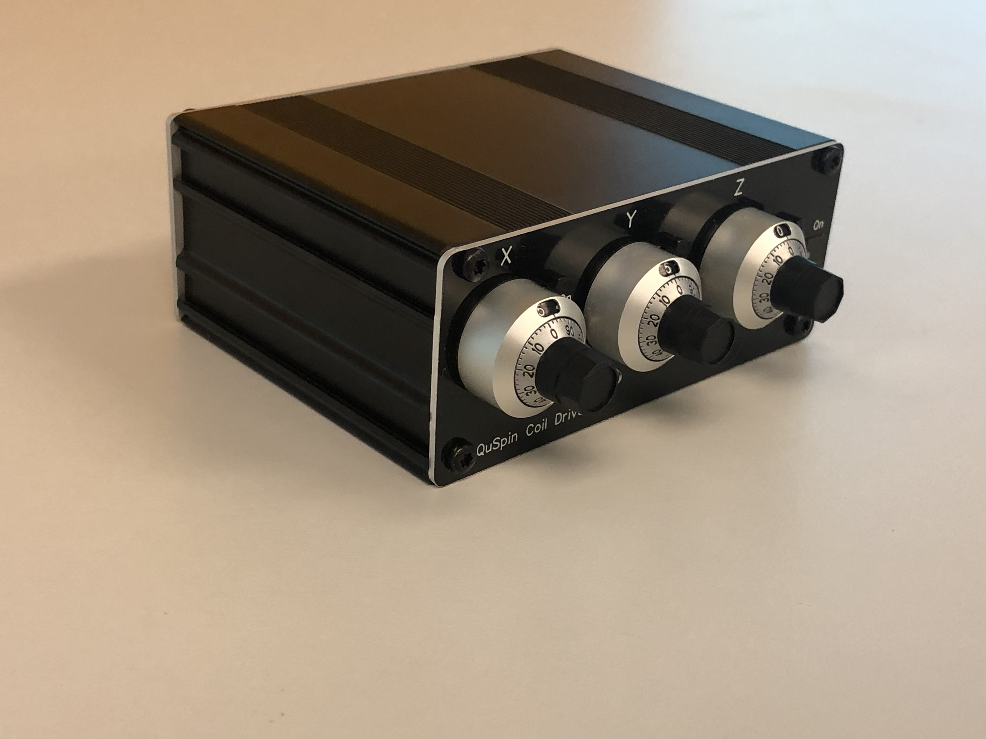

Figure 1: Front panel

## Front Panel (Figure 1)

* There are three, 10-turn potentiometers to control output voltages of the three channels (X, Y, Z). Setting the dial to 5.0 corresponds to 0-volt output. Setting the dial at 0.0 or 10.0 corresponds to max output (+/-4.096 volts)
* There is a power switch.
* There are three mechanical switches between the the dials to activate or disable external voltage control.

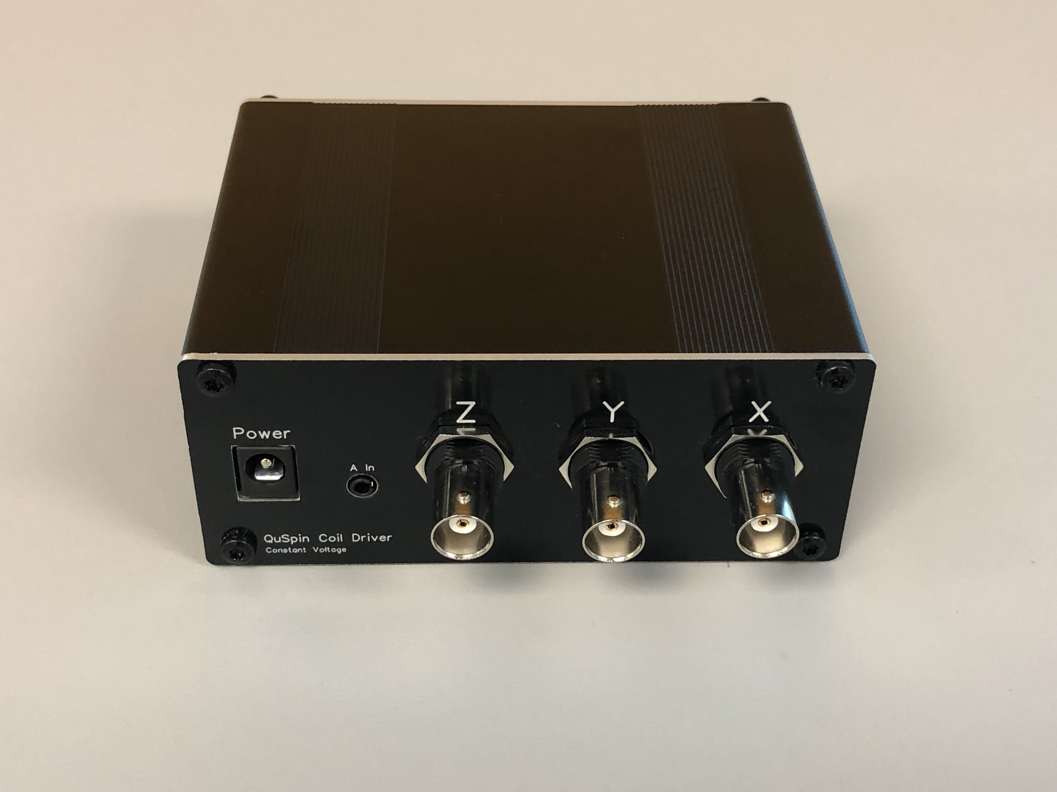

Figure 2: Back panel

## Back Panel (Figure 2)

* There are three BNC outputs corresponding to each of the three-output channels.
* There is a power input connector (+19 V).
* There is an external voltage input connector (2.5 mm audio/4-pin)

# Included with each coil driver

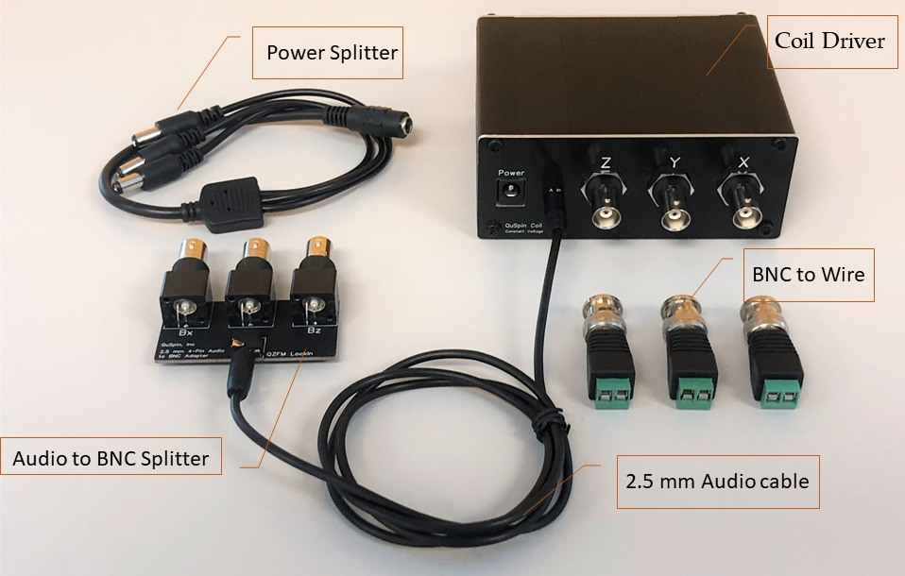

Figure 3: What’s included. Power adapter not shown.

1. A coil driver unit
2. +19V wall plug adapter (110/240 AC input)
3. A +19V splitter cable (optional/shipped with more than one coil driver unit). A single power adapter can drive 8 coil driver units (24 channels)
4. A 2.5 mm audio to BNC splitter board for external voltage input
5. 3x BNC to wire adapter

## Schematic



Figure 4: Schematic

Figure 4 shows a basic schematic of each output channel.

1. The potentiometer generates a clean, adjustable voltage between +/- 4.096 V.
2. The external control voltage is divided by 10 and then added to the voltage generated by the potentiometer. The external input voltage range is +/- 5V. (Higher input voltage will not kill the driver.)
3. The combined voltage is low-pass filtered (first order, 70-Hz).
4. The filtered voltage is buffered using high current amplifier.
5. A 68-ohm current limiting resistor is used before the output to prevent excess short-circuit current.

The external control voltage is divided by 10x to reduce noise contribution from external control voltage signals.

## Connecting to external coils

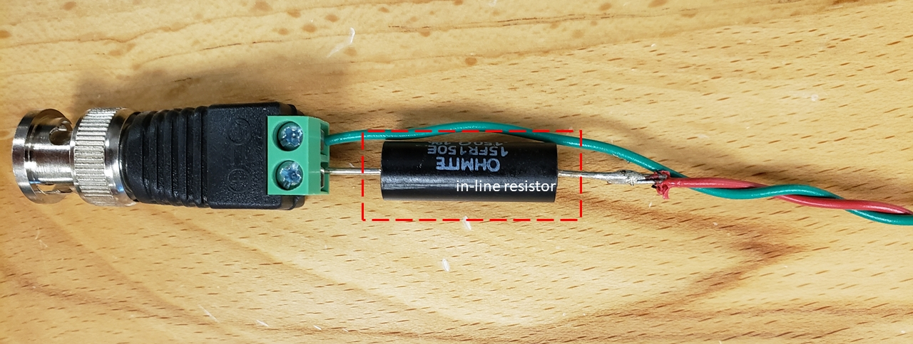

Figure : Connect the coil wires to the coil driver using BNC-to-wire adapter. Add an resistor in series (in-line resistor) as shown the picture if needed.

Connect the coils to coil driver using BNC-to-wire adapter as shown in Figure 5. Add a series resistor (in-line resistor) if necessary. Choose a low-tempco resistor (25 ppm/deg. C) when possible.

## Adding a series resistor (**Important**)

The coil driver is a constant voltage source. Therefore, the current passing through the coils is given by,

icoil = Vcoil driver/(Rcoil + 68 ohm + Rin-line)

where Rcoil is the coil resistance, Rin-line is the series resistance added to the coils, Vcoil driver is the voltage output of coil driver, and icoil is the current passing the compensation coils.

The output voltage noise of the coil driver is constant regardless of the output voltage setting; therefore, using the largest possible Rin-line value reduces current noise, and therefore magnetic field noise introduced by the coil driver.

Two methods are described below to determining the value of Rin-line series resistance.

### *Method-1 (slightly more complex but thorough)*

* *Estimate the coil current-to-field conversion ratio.*

If you do not already know this number, and if you have simple circular/square coils mounted inside the room, use the following formula for a crude estimate of the coil current-to-field conversion: 2x10-7 *n*/*r* (Tesla/Amp.), where *n* is the number of turns in the coil and *r* is the approximate coil radius.

* *Estimate how much current you will need.*

Let’s say the max. residual field you want to compensate is 10 nT. Using the max. field number and your coil current to field conversion ratio, you can estimate the maximum current the coil driver must deliver.

For example, if the coil current-to-field conversion is 2.5 T/A, and if you want to generate 10 nT cancellation field, then the total current coil driver must deliver is 4 mA.

* Because the max. voltage output of the coil driver is 4 volts, the in-line resistor you must use is

R_inline = 4 V/4 mA – (68+coil resistance)

The coil resistance can be measured using a regular multimeter. Choose the nearest popular value of the resistor. You can order resistor online from places such as Digikey. For optimal performance, use low temp. coefficient resistors (< 25 ppm/c) if available.

### Method-2 (Trial-and-error)

* Set the coil driver potentiometers at the 0 Vdc output (5.0 on the potentiometer dial)
* Adjust each of the potentiometers to zero the background field
* If the value of the potentiometer dial when the zero field condition is reached is between 4.5 and 5.5, then you likely need the in-line series resistance.
* Experiment with adding R_inline values (start with 200 ohms for example) and increase the resistance until when the POT dial is between (7.0-10.0 volts) or between (0-3.0) when the zero-field condition is reached.

## Custom Modifications

If you wish to make modifications to the driver, please get in touch with us and we will send you the schematic or email you instructions. You can also specify custom modifications before shipment.