## Objective: Accurate field zeroing using QZFM sensors inside a magnetically shielded room.

## Background

For MEG and other sensitive experiments in which sensors are not held on a rigid platform, it is critical to reduce magnetometer sensitivity to movement as much as possible.

The OPMs are vector magnetometers and they measure projection of the background field along the sensitive axis of the magnetometer, i.e. B_meas = B0 Sin[θ], where B0 is the magnitude of the local background field and θ is the angle between the sensitive axis of the magnetometer and the B0 field. Thus, even inside a high-quality shielded room with low background field, say 5 nT, just 1-degree of sensor rotation can produce up to 0.7 nT change in the magnetometer output. Such a large rotation induced response from the magnetometer can completely drown the signals of interest from the brain.

Since movement induced response is directly proportional to B0, to make the OPMs somewhat immune to movement, B0 must be reduced to as much as possible.

**Requirements:**

* **1 QZFM sensor (Gen-1 or Gen-2)**
* **3 orthogonal large surface area coils for cancelling residual fields**  (for more information, please visit <http://quspin.com/low-noise-coil-driver/>)
* **1 three channel low noise coil driver**

# Offset Calibration Procedure

***Offset Calibration:*** Although QZFM is based on zero field resonance, the magnetometer has internal offsets that vary from unit-to-unit. To find absolute zero field, it is necessary to first calibrate sensor internal offsets which may be as large as few nT. We expect the internal offsets to remain fixed over time, and it is likely safe to go through the calibration process once every few months.

**Step 0:** It is assumed that three-axis coils are installed inside the shielded room and that the coils are powered using a low-noise coil driver (<http://quspin.com/low-noise-coil-driver/>). Set the coil driver outputs to zero volts before turning it on (5.0 potentiometer setting on our coil driver)

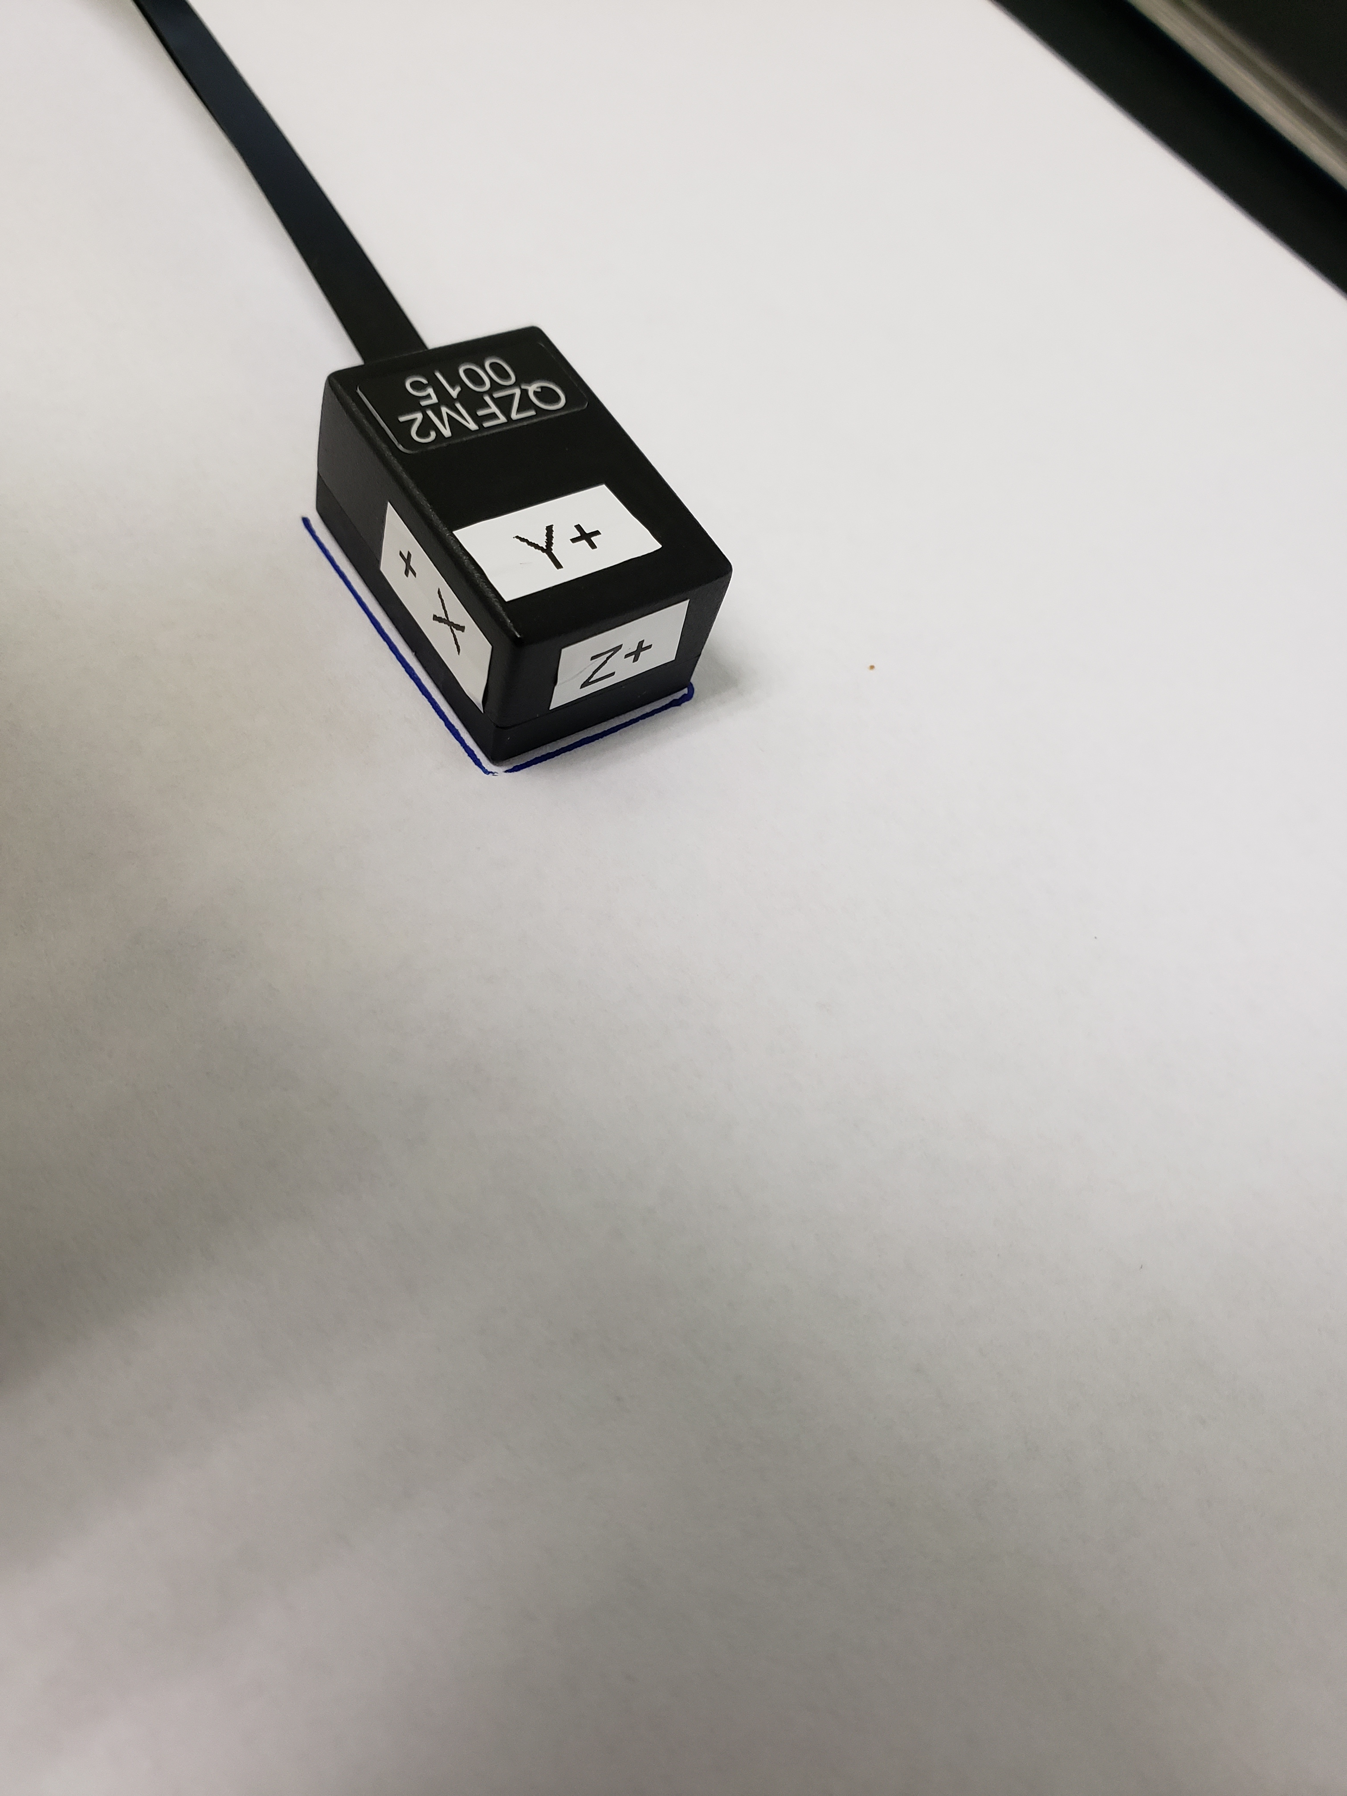

Figure 1: Place sensor on a piece of paper and draw the outline.

**Step 1:** Use one QZFM as a reference sensor (or a low noise triaxial fluxgate). Place the sensor on a non-magnetic table somewhere in the middle of the MSR near the MEG helmet. Ideally, align the sensor axis to be along the x, y, and z axis of the external wall mounted coils. Draw the sensor outline with a marker to define the placement of the reference sensor. Eyeball the location of the vapor cell (can be found here: <http://quspin.com/products-qzfm/qzfm-dimensions/>). For added convenience, place identification marks to identify each of the six faces with x+, y+, z+ and so on as shown in Figure 1.

**Step 2:** Place the reference sensor in **dual-axis mode** and press field zero. Wait 5-10 seconds then press field zero again to deactivate field zeroing mode, then press calibrate.

**Step 3:** Once the sensor is calibrated, press the field zero button once again and this time leave the sensor running in the field zeroing mode.

**Step 4:** Adjust the potentiometers on the coil driver such that the field values displayed (B0, By, and Bz) on the user interface are all below 100 pT. If the starting background field values are quite large (>10 nT), it may be necessary to repeat from step 2.

**Step 5:** Note down the B0, By, Bz field values. The values may fluctuate a bit so use approximate values readings. Call these values x+, y+, z+. (B0 can be used as Bx field value)

For example, x+ = 100 pT, y+= 180 pT, z+ = -95 pT

**Step 6:** Flip the sensor 180 degrees about the cable axis as shown in the figure. This will flip the y-axis and the x-axis of the sensor (see Figure 2). Place the sensor approximately in the same location. Without adjusting the potentiometer note down the B0 (Bx), By, Bz values on the user interface again. These values of Bx and By correspond to x- and y- respectively.

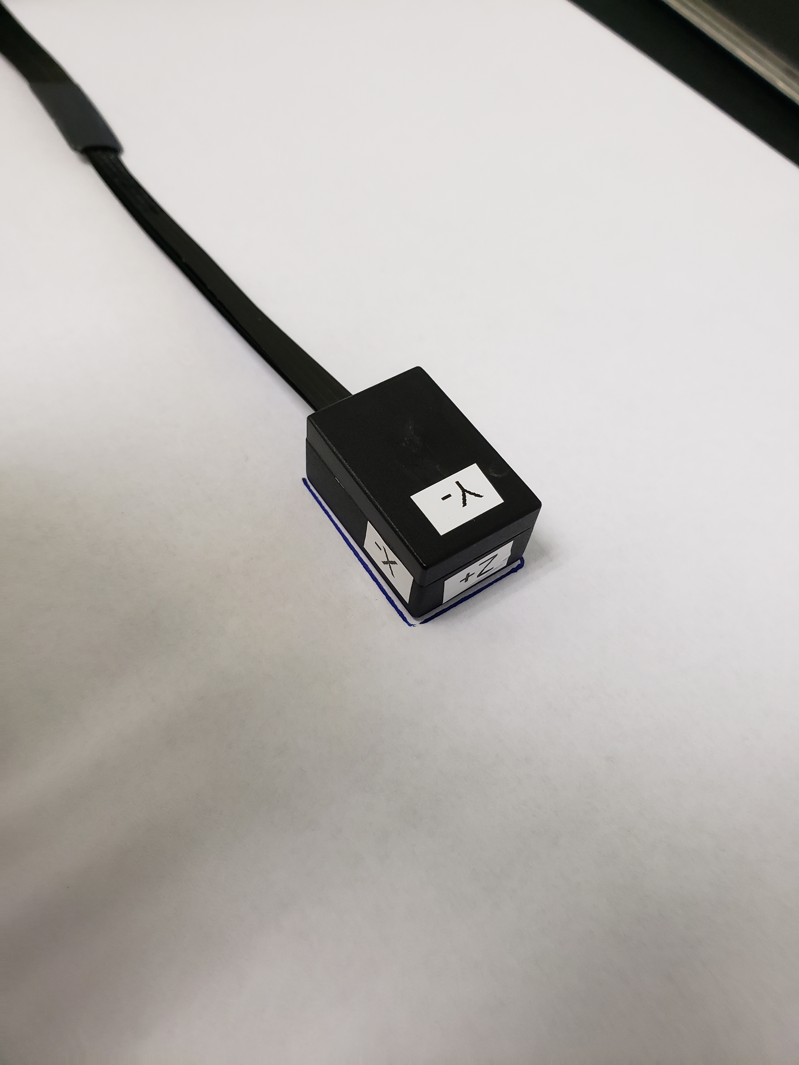

Figure 2: Sensor rotated 180 deg. about the cable axis, to flip the y and x directions.

For example, x- = 2000 pT, y- = -1800 pT, z+ = -85 pT

**Step 7:** Flip the sensor by 180 degrees once again to go back to the original starting orientation to ensure the x+ and y+ values are close to the initial x+ and y+ readings obtained in step 4. Repeat step 5 and step 6, two or three times to get an average reading for x+, x- and y+, y-.

**Step 8:** Based on the average reading of x+, x- and y+, y-, the sensor internal x, y offsets can be estimated as,

Xoffset = (x+ + x-)/ 2 and Yoffset = (y+ + y-)/2



Figure 3: Flip the sensor to reverse the z-axis. Keep the cell position unchanged.

**Step 9:** Repeat the steps 5, 6, 7, 8 but this time after rotating the the sensor in a way that flips the z-axis. Eyeball the vapor cell placement when the sensor is z-axis is flipped such that the cell position is roughly the same in both flipped and un-flipped orientations (see Figure 3).

**Step 10:** Once all three offset values (xoffset, yoffet, zoffset) have been found, store the numbers for future use.

# Field Zeroing

After obtaining the xoffset, yoffset and zoffset values, steps 1-10 can be skipped and simply follow the steps 1a-3a below.

**Step 1a:** Place the reference sensor in dual axis mode, field zero and then calibrate the sensor.

**Step 2a:** Place the sensor in field zeroing mode and leave it running in this mode.

**Step 3a:** Adjust the potentiometers on the coil driver such that the B0, By, and Bz values on the user interface correspond to the xoffset, yoffset, zoffset values respectively to get an accurate zero field background.

Depending on your shielded room characteristics, you may need to need to repeat the steps 1a-3a every time the room is reopened. It is possible to automate the background nulling procedure if you have access to NI DAQ with three analog outputs. If you are interested in automating field nulling process, please get in touch with us for more information.

**Step 4:** The reference sensor can be released from field zeroing mode after background field nulling process is completed.